Day 3 Assignment
Abhinaash Tiwari
3 December 2025

Tasks:
- List all employees older than 25.
SELECT * FROM org.Employees WHERE Age > 25;
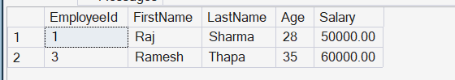
- Return the latest branch (highest BranchId).
SELECT TOP 1 * FROM org.Branches ORDER BY BranchID DESC;
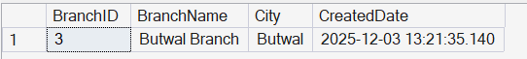
- List all unique branch cities.
SELECT DISTINCT City FROM org.Branches;
